St Lawrence CE Primary School
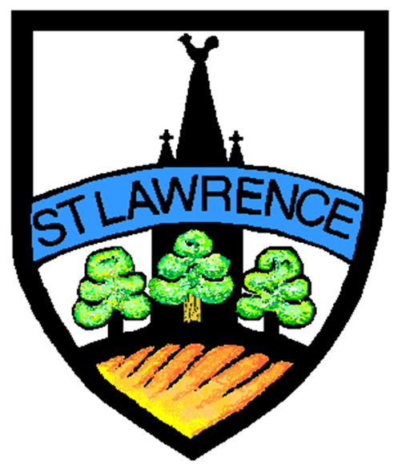


Reading Together
- Questions/Ideas for Discussion -
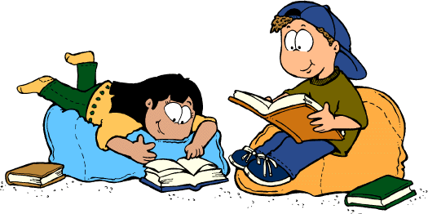


♦
♦
♦
♦
♦
Predictions
What does the front cover tell us about the text? What might the story be about?
Where do you think the book is set? When do you think it was written?
What questions does the blurb leave us with?
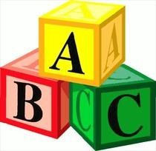

♦
♦
♦
♦
♦
♦
♦
♦
♦
♦
♦
Word Reading
Where/what is the title? Who is the author?
What graphemes/ digraphs/ trigraphs can you find? What words do you recognise?
How can we segment this word?
What do you notice about the words? (e.g. rhyme, same phoneme) What clues are there in the pictures?
What do you do when there is a full stop? How can we read tricky words?
How do we read a question?
How should this character sound? (What voice would they use? How are they feeling? What are they doing?)


Retrieval of information
♦
♦
♦
♦
♦
♦
♦
♦
♦
♦
♦
♦
♦
♦
♦
♦
What happened in the story? What was it about? Who is your favourite character?
When did (this) happen?
Who is the main character? What other characters are there? Where is the text set?
What happened after...? Who is the narrator?
Find a quote to show... What are the key events? What word suggests that...?
Identify a word from this paragraph which shows… What is ‘animation’? (subject specific language) True/False based on text
Give one example…
Match answers from text evidence Which character…




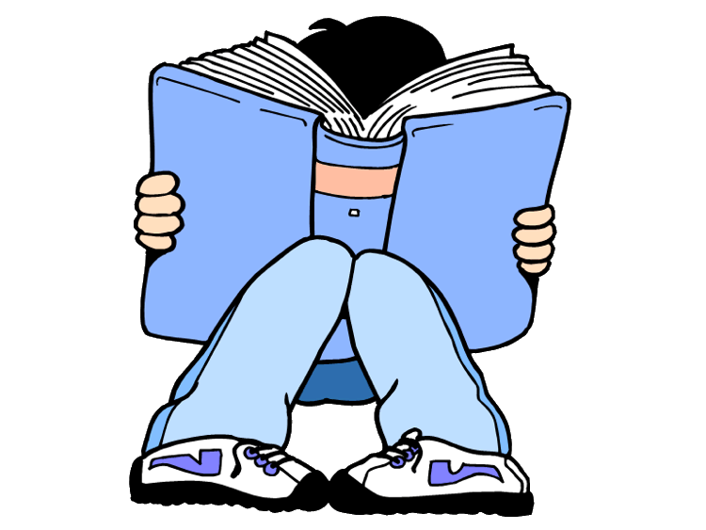
Inference and Deduction

- What do you think this text will be about?
- Who is speaking in the story? Who is the narrator?
- How is the character feeling?
- How do you know (they) are feeling this way?
- What is/are the character/s doing to suggest that...?
- What does (this) mean?
- How do they react?
- How would you feel?
- Have you been in this situation?
- How do you know that...?
- What impression do you get of the character? Why?
- What does this quote suggest about the setting?
- Explain the use of the word…
- Why did the character….?
- Fill in the thought bubble: what is this character thinking?
- If you made a film of this book, what type of music would you use for it?
- How are the experiences of these two characters similar?
- Why did the character feel…….?
- How did the character feel before… and after…?
- How did the character’s feelings change?
- Why have the character’s feelings changed?
- What would you do/ask?
- What evidence is there that…?
- What is the character’s attitude towards…?


Structure and Purpose

- What do you notice about the letter (font) size?
- Why would (this) information be bold?
- Find a caption.
- What punctuation can you find?
- How is the text organised? How is the information arranged?
- Why is (this) described first?
- How does the writer organise the information?
- What do you notice about the sentence lengths?
- How does the structure of the text support its purpose/theme?
- How does the text build up?
- What is the turning point?
- How does the organisation of the text contribute to the effect on the reader?
- How does the first sentence help to guide the reader?
- How does this paragraph link back to the opening paragraph?
- How does the writer link the conclusion to the introduction?
- How does the writer build up to the conclusion?
- Sequence these events from the text
- Label these parts of the text
- How does the timeline/image/diagram/layout make it easier to under- stand?
- Why is this element in bold/underlined/in italics?
- What would be a suitable caption for this image?
- What would be a suitable heading for this text?
- Give two features that tell you it is written as a (genre).


Language

- What rhyming words do you notice?
- What are the repeated words?
- Why is (this) a good word?
- Find a conjunction.
- What is the purpose of saying...?
- Why is (this) a good choice of word to describe...?
- How does the author use sentence lengths to contribute to what is happening?
- Why does the author say... to describe...?
- Find one word/phrase that suggests that...
- What is the effect of...?
- How is language used to show...?
- Explain how the use of language in this sentence shows…
- Underline the word/noun/verb/phrase which shows that…
- What does the choice of language suggest…
- How does the choice of language create the impression that…
- Why is this style of formal/informal language used in this text?
- What words help the reader to imagine…
- Which phrase best describes…
- Explain two ways in which this sentence makes the reader…
- Why is the word … in inverted commas/italics?
- Choose a word to describe this character. Why?
- In what way is…like …?
- Which parts of the text tell you….?


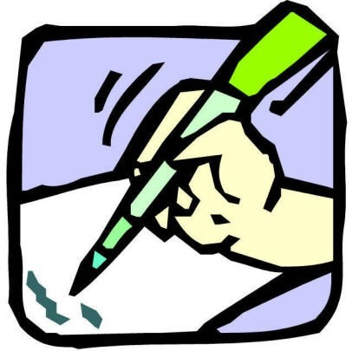
Reader’s/ Writer’s Viewpoint

- What is your favourite book? Who is your favourite author?
- What do you like/ dislike when reading? Give a reason why.
- What does the writer think of (this)?
- How does the writer feel about…?
- Who does this character remind you of?
- Why have they written this book?
- How do you know the writer has a positive/ negative attitude to- wards (this)?
- How does this make you feel? Why do you think the writer wants you to feel like this?
- What is the effect on the reader? How has this been created?
- How do you know the writer feels like (this)?
- What do you think the writer thinks about this topic?
- How does the writer show his positive / negative attitude to- wards…?
- How does this article create the impression that…?
- Which elements of this text are persuasive?
- Why does this section begin with a question?
- What is the main purpose of this text?
- Which of these texts would inspire you to…?
- How does the author make you feel…?
- Why has the author included…?
- How can you recognise the attitude of this character?


Features and context

  - What usually happens to good/ bad characters in texts?
  - What genre of writing is this? How do you know?
  - How would you describe this text?
  - When is the story set? Where is the story set?
  - What similarities/ differences do you notice in this text with others you have read?
  - How is this version similar/ different?
  - When was this book written? How can we find out?
  - Typically, what would you expect from this style of text?
  - What is the effect of the reader’s/ writer’s context on the meaning of the text?
  - What are the typical conventions of a writer from this time?
  - How does the context of a reader/writer affect the overall meaning of the text?
  - How has the meaning changed over time?



Our main aim at St Lawrence is that children will develop
a love of reading.



